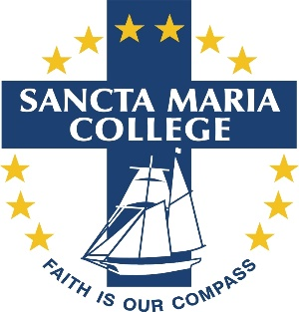

Sancta Maria College opened in 2004 and is a vibrant community of learners comprising of 1000 students and over 100 staff, located in Flat Bush, Auckland.
Receptionist
Person Specification
- Demonstrates and supports our Special Catholic Character
- Is able to work with a team of Administration staff in an effective and efficient manner.
- Can maintain professionalism and confidentiality
- Builds supportive, collegial relationships with all staff and students.
- Has excellent listening, verbal and written communication skills.
- Work is completed to a high standard
- Is time-efficient, resourceful and effective
- Has and uses initiative
- Is a high-level thinker and will respond to tasks independently
- Has a level of computer skills and knowledge to meet the requirements of the position
- Can multi-task and be flexible
- Fosters positive relationships with others
- Enjoys working in a learning environment that has a diversity of cultures
- Presents well with a caring nature
- Has a tidy and appropriate dress attire for a front of school reception area

