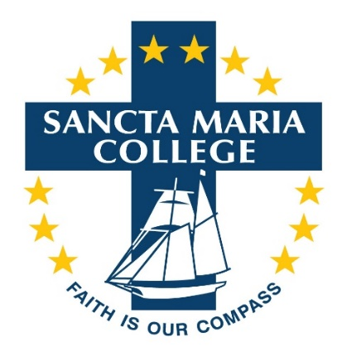
Do you have a passion for sport?
Are you well organised person with great interpersonal skills?
If so, we need you as our
SPORTS COORDINATOR
Sancta Maria College is a Year 7-13 State Integrated Catholic Secondary School with 1000 students in Auckland’s South Eastern Suburbs. We seek an enthusiastic and self-motivated person who has passion for sport in schools and is energetic, innovative and professional.
This is a Permanent, Full-Time position: 40 hours per week which includes out of school hours as required. Commencement date: Tuesday 26 January 2021.
Purpose and primary objectives
To provide effective and efficient management and coordination of the college’s Year 7-13 sports programme, leading to:
- Quality, well organised sports programmes that meet the various needs and interest of all students
- Enhancing the profile of sport at the college and within the school community
- Encourage high levels of student participation and excellence in sporting competitions, events and recreational opportunities
- Provide a safe and enjoyable sporting environment for all students
The successful applicant will demonstrate
- Passion for building positive relationships
- The ability to develop, implement and coordinate programmes and events
- Knowledge and experience of a variety of sports codes
- Commitment to the holistic development of young people
- Strong organisational, problem solving and communication skills
Experience in the secondary school sports environment is an advantage.
Candidates will be shortlisted and invited for interviews soon after the closing date
Anyone wishing to visit the College before completing an application may contact Jason Crummer, Director of Sport, for an appointment to view the campus via email j.crummer@sanctamaria.school.nz or phone (09 274-4081 ext.293).
Full job description and application form are available on our school website: www.sanctamaria.school.nz.
Completed application form, covering letter and CV are to be emailed to j.crummer@sanctamaria.school.nz. Applications close 4.00pm, Friday 6 November 2020

